Lecture 11, September 28, 2010 (Key Points)

11. Self-Similar Drainage Network Topology Models
Channel networks are example of self-similar branching patterns. Self-similarity in channel networks plays a fundamental role in understanding the presence of power laws in floods from hydrologic processes. It will be discussed later in this course.
Do Horton laws and other morphometric relationships represent gross empiricism? Do they have a physical basis rooted in the transport of water and sediments over landscapes? These are some of the key questions, which have instigated the development of geomorphic and hydrologic models and theories over the last fifty years. We can group these theories into two broad categories. The first set of theories begin with physical continuum equations for mass and momentum governing transport of water and sediments on landscapes, and study the development of channel networks as discrete patterns that are formed due to erosion on an otherwise 'smooth' landscape. These problems are analytically complex and most of the approaches have relied on numerical solutions of governing equations. They are outside the scope of this course.
Theories in the second category start with a set of mathematical assumptions on the branching and geometric patterns of channel network, and then analytically derive Horton laws and other morphometric relationships from these assumptions. Three comprehensive channel network models have been introduced with in the last forty years. The most well known of these three is the random model (Shreve, 1967 reproduced in Jarvis and Woldenberg, 1984). Second is the mean self-similar model of Tokunaga (1966), which went largely unnoticed until recently (Peckham, 1995). The third is a new class of models called the random self-similar networks (RSN) (Veitzer and Gupta, 2000; Troutman, 2005). They all start with different sets of mathematical assumptions on the branching and geometric structure of channel networks, and derive Horton laws and other morphometric relationships from their respective assumptions. We will briefly explain the principle assumptions underlying each model, and make some remarks about how well they compare with each other and how successful they have been in explaining empirical Horton laws. We will analyze the Tokunaga model in greater detail and show how it gives rise to Horton laws. These calculations are simpler to understand than in the other two models. It requires advance statistical background, and is outside the scope of this course.
In addition to their importance in the context of river basin hydrology, network models serve two additional purposes. First they put diverse empirical morphometric relationships in a common mathematical framework. Second, they make predictions of purely empirical relationships, which serve as a diagnostic tool for how well a mathematical framework holds in nature. When the predictions of a theory don’t explain observations, it becomes necessary to develop new theories and thereby gain new understanding about the phenomenon. For example, in the context of channel network models, major deviations of random model predictions from data for large networks instigated the development of a new statistical theory of channel networks (Veitzer and Gupta, 2000; Troutman, 2005).

11.1 Three Channel Network Models
Shreve (1967) proposed the random model in the middle sixties. It introduced the key ideas of magnitude, link, topology, and randomness as the fundamental concepts for understanding channel network structure. Its impact on the geomorphology and the hydrology literature was enormous. The basic idea underlying the random model is the notion of topological similarity or dissimilarity between two branching networks. Specifically, given that the number of sources, called magnitude, is n, a formula for the number of topologically distinct binary trees,, is given by

(11.1)

Known as the Cayley formula, it was first obtained in 1859. As a simple exercise, it is easy to check that for, n =2, 3, 4,..., =1, =2, = 5, …, respectively, and grows very fast with n. The random model assumes that, "All topologically distinct binary trees with the same number of sources are equally-likely to occur in nature”. Shreve (1967) derived the Horton law of stream numbers in the limit as , and predicted Horton bifurcation ratio, . He also predicted other topological features from this basic postulate. A detailed discussion of this statistical theory is beyond the scope of this course. The original papers of Shreve are given in Jarvis and Woldenberg (1984) with an editorial commentary.
Second is the Tokunaga model, which is based on two sets of assumptions. Let denote the mean number of streams of order joining the number of streams of order . We define a tree to be mean self-similar if the following relationship holds,

(11.2)

Topologically speaking, this means that do not depend on the orders of the truck stream, ω, and the side stream, but only on the difference, . Therefore, , the mean number of side tributaries of order 4 joining a stream of order 5 is the same as the mean number of side tributaries of order 2 joining a stream of order 3, or the mean number of side tributaries of order 1 joining a stream of order 2, and so on. The same mean self-similarity property holds for all side tributaries. ’s are called the network generators. The second assumption of Tokunaga model is that, , which implies that,
(11.3)
It is also known as Tokunaga self-similarity. Peckham (1995) gives for a more detailed explanation of this model. For example, it has been shown that the random model obeys Tokunaga self-similarity with a=1 and c=2.
Analysis of a dozen large river basins have shown that their bifurcation ratios vary between 4.1 to 4.8, which are significantly larger than 4, the value predicted by the random model (Shreve, 1967). These observations of large river networks use three-dimensional digital terrain data, or DEM. Before this and other similar data analyses were undertaken, it was believed that most rivers have, and the deviations from 4 reflect statistical deviations due to small sample sizes. The data analyses during the 1990s have convincingly shown that this belief is incorrect, and that the random model does not correctly describe the geometry and topology of real channel networks.
The primary motivation for the development of the RSN came from the need to develop a model that can accommodate systematic and large deviations between observations and the random model predictions of Horton laws and other morphometric quantities (Veitzer and Gupta, 2000). The RSN construction is similar to the construction of fractals. Unlike the random model, the RSN model is based on Strahler ordering rather than on link magnitude. Unlike the Tokunaga model, the RSN model is not built on the side tributary structure and is statistical in nature. Simply introducing stochastic assumptions in the Tokunaga model that was attempted in the literature (Cui et al. 1999) is very different from a RSN. A discussion of this technical issue is beyond the scope of this course.
RSNs are constructed by replacing, in an iterative fashion, all the links of a network by randomly sampled generators. The process is initiated with a single link, and it is replaced with a randomly sampled generator. All the links in the resulting network are replaced with randomly sampled generators, and so on. Thus, at each step of the iteration process, the branching structure of the network becomes more complex. Each link replacement depends on whether the link to be replaced is “interior” or “exterior,” where exterior links are defined as those with no upstream connecting links. Interior links are replaced by interior generators, and exterior links likewise are replaced by exterior generators constituting a different population. Fig. 11.1 (Mantilla et al., 2010) illustrates a network after two iterations of the replacement process.

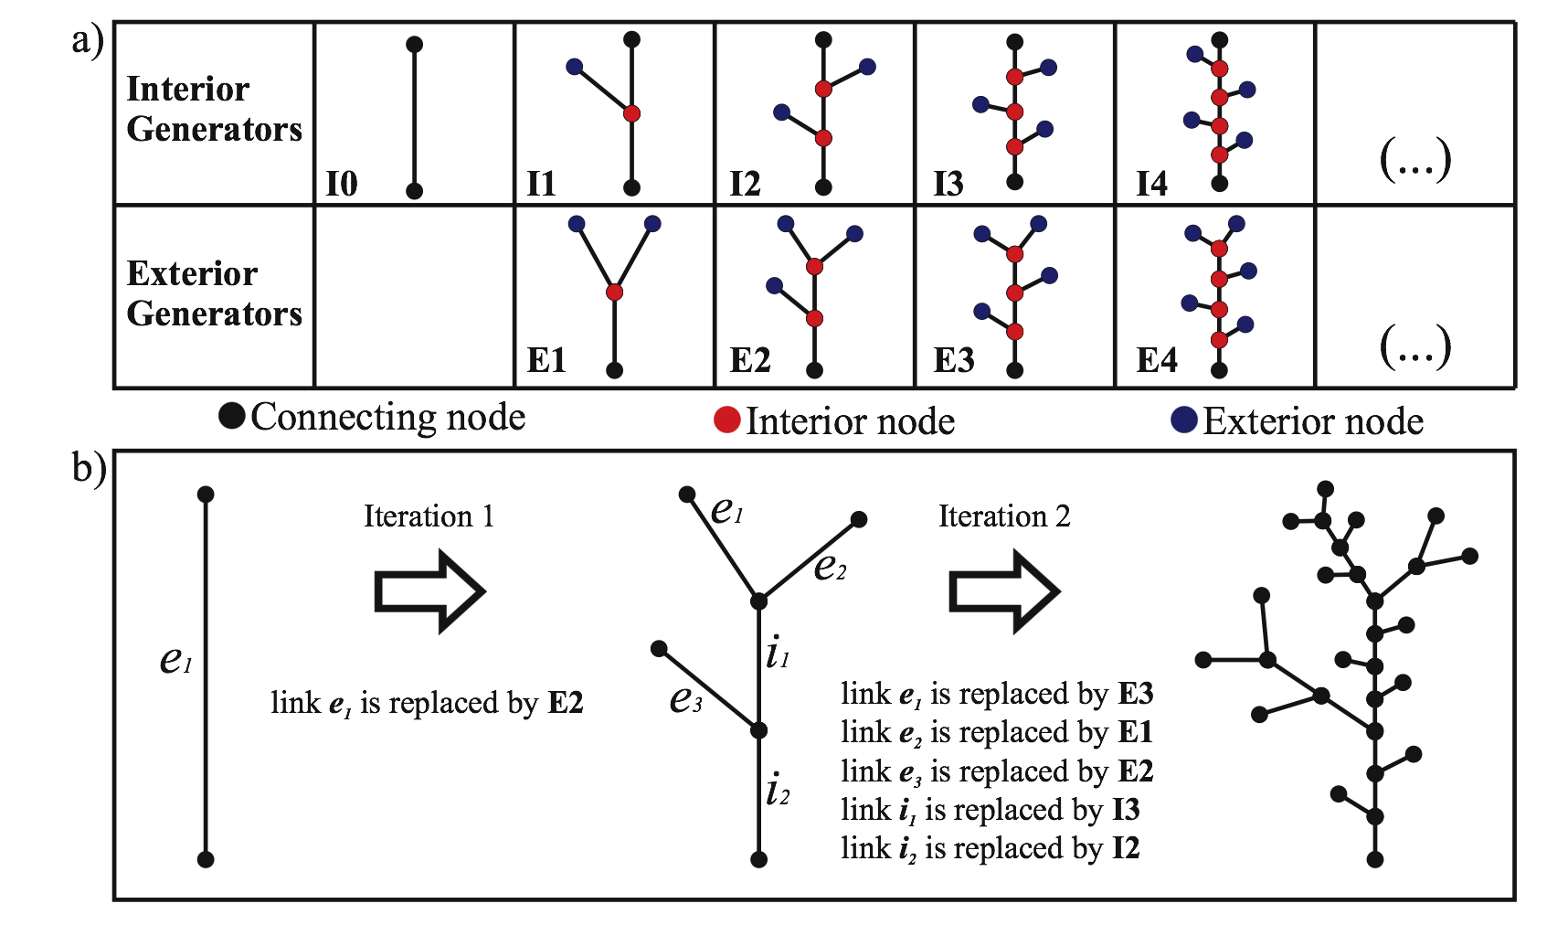
Figure 11.1 a) Populations of interior (I) and exterior (E) generators. The number
represents nodes in a generator. b) Two replacement steps in RSN
Construction of a RSN requires specification of two probability distributions governing the random sampling of the different generator types, and all sampled generators are assumed to be mutually independent. RSN predicts the Horton law of stream numbers in the limit as the network order, . Predicted values of can be either 4 or different from 4 depending on the values of the parameters describing tree generators. Moreover, a subclass of RSN models exhibits Tokunaga mean self-similarity as a special case given by Eqs. (11.2) and (11.3). The mathematical analysis of the RSN model is of an advanced statistical nature, and is beyond the scope of this course.

11.3 A Basic Recursion Equation for Tokunaga model of river networks
We will use the mean self-similar tree branching structure defined by Eq. (11.2), and the Tokunaga tree generators given by Eq. (11.3), to construct a mean self-similar channel network. Then we will derive an expression for the bifurcation ratio in terms of model parameters c and a in Eq. (11.3). This example illustrates rather nicely how mean self-similarity produces the Horton law of stream numbers.
From the definition of stream ordering we know that a minimum of two streams of order are needed to form a stream of order . It implies that, . However, there is no upper limit to how large can be. Recall that in most drainage networks is observed to be between 3 and 5. The most important insight to be gained from Tokunga model is that a value of higher than 2 is determined by the topology of the side tributary structure. Tokunaga model suggests that perhaps the simplest set of assumptions governing the topology of river networks, which can produce a value of larger than 2, are contained in Eq. (11.2) and Eq. (11.3).
The construction of a Tokunaga network is similar to the construction of the Koch curve, or any other deterministic fractal curve. However, there are also basic differences that we will point out. Take a stream of unit length of order , =1. Attach two streams of order () at the source and streams on the side. The total number of streams of order () is given by,

(11.4)

In the second stage of construction, each stream of order () is assigned a stream of order (-2) at the source, and streams on the side. The trunk stream of order is assigned additional streams of order (-2) on the side. Therefore,

(11.5)

Continuing in this manner, a general recursion equation is obtained,

(11.6)

After a change of variables, , Eq. (11.6) becomes,

(11.7)

This is a basic recursion equation, which can be solved either numerically or analytically if the tree generators are known (to be continued…).

References

Cui G, B. Williams and G. Kuczera. A stochastic Tokunaga model for stream networks. Water Resour Res, 35: 3139–47, 1999.

Jarvis, R. S., and M. J. Woldenberg, (Eds.) 1984. River Networks, Benchmark Papers in Geology, V. 80, Hutchinson Ross, Stroudsburg, PA.

Mantilla, R., B. Troutman and V. Gupta, 2010. Testing statistical self-similarity in the topology of river networks, J. Geophysical Res. (In press).

Peckham, S., 1995: New Results for Self-Similar Trees with Applications to River Networks, Water Resour. Res., 31(4), 1023-1029.

Shreve, R. L., 1967: Infinite topologically random channel networks, J. Geol. 75:178-186.

Tokunaga, E., 1966: The composition of drainage networks in Toyohira river basin and valuation of Horton's first law (In Japanese with English summary), Geophys. Bull. Hokkaido Univ., 15: 1-19.

Troutman, B.M., 2005: Scaling of flow distance in random self-similar channel networks. Fractals. 13(4), 265-282.

Veitzer, S. and V. K. Gupta, 2000: Random self-similar river networks and derivations of generalized Horton laws in terms of statistical simple scaling, Water Resour. Res., 36(4): 1033-1048.

